I have make figma design of my react native app.
I have many pages ie: signin signup, home page where pprofile and all fiunctions are displayed.
Pages
- Signin signup
- home page
- live stock management
- health
- production and sales
- finance and operations
- staff management
- inventory management
- crops detail
- AI health detection (coming soon feature ).
____________________________________

Signin signup :
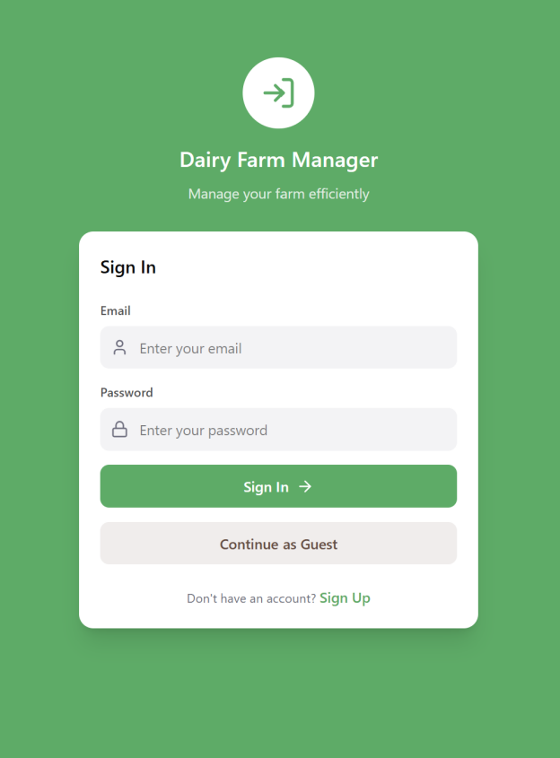 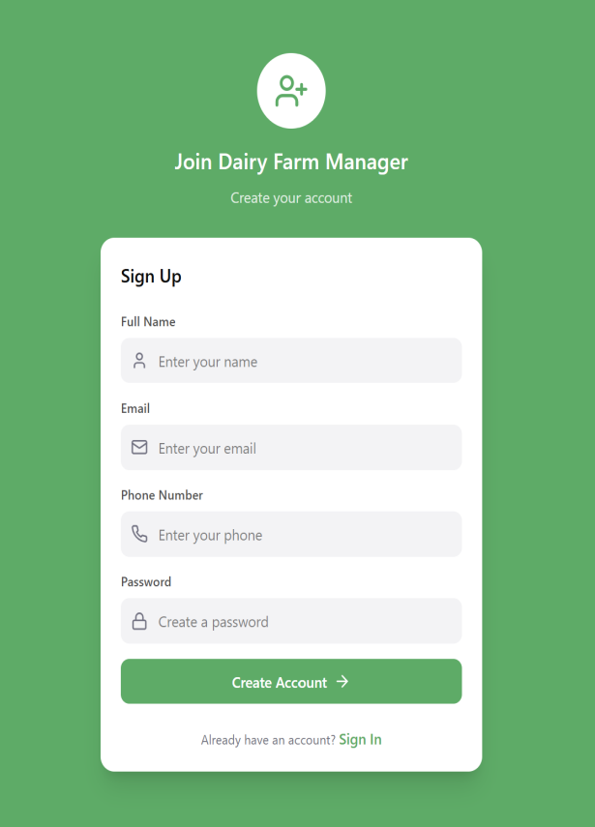
And also have continue as guest option.

Home Page:
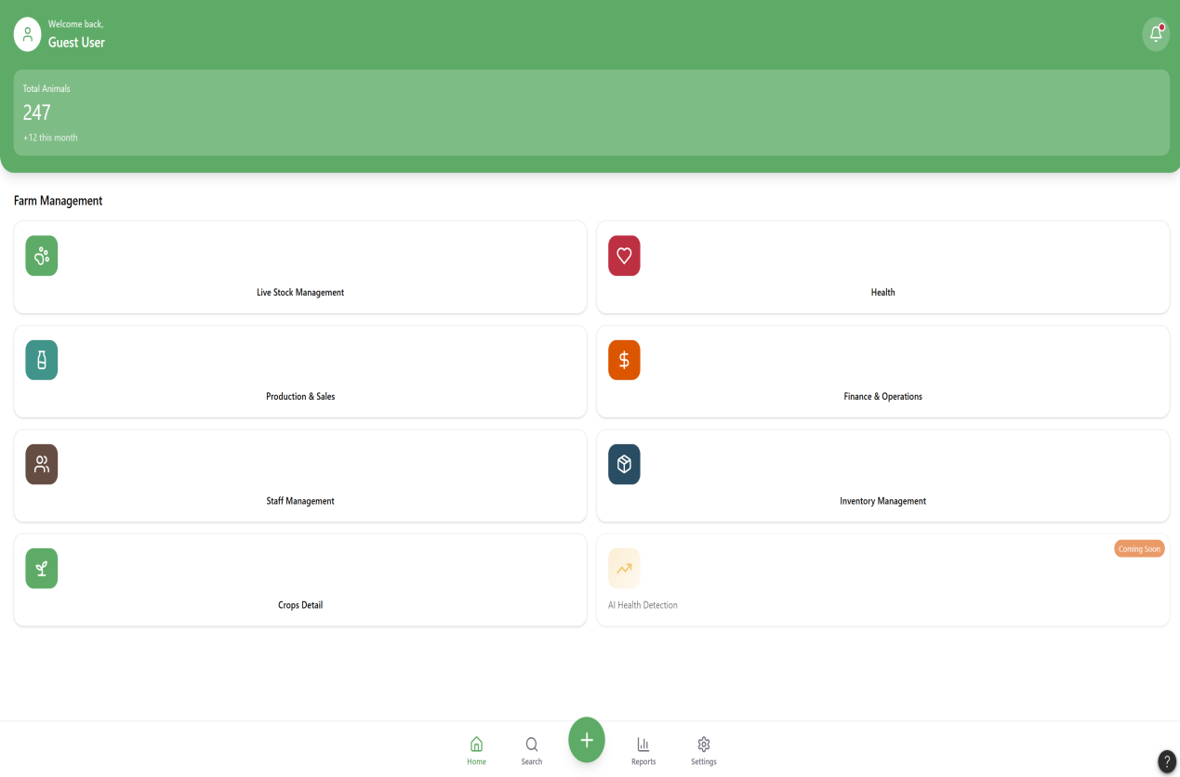
This home page has all feature and this design is for web make for mobile in this screenshots we have looking pages are big in sizes.

Profile:
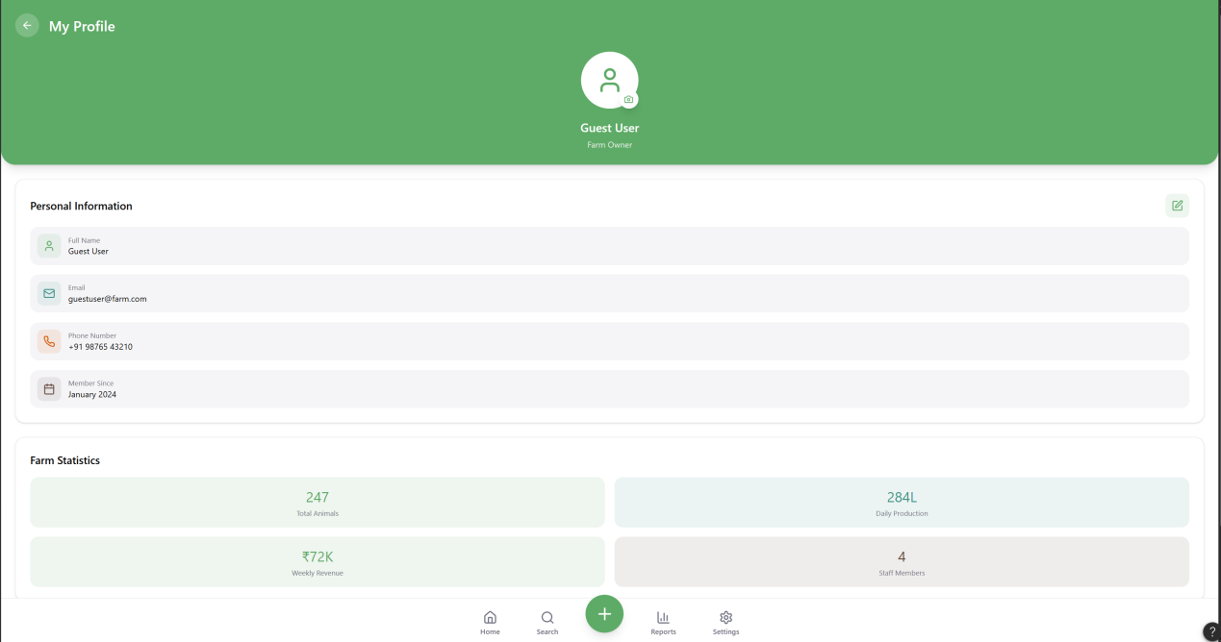

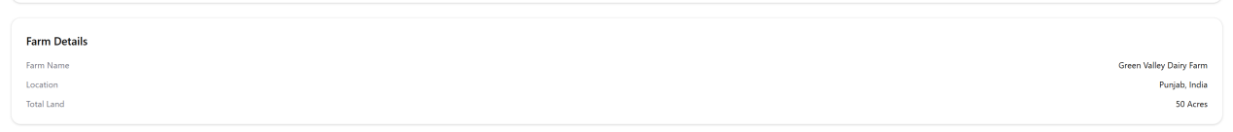
This page also have farm info in the end. I m unable to take screenshot full that why we have two features .
We can also make changings like edit profile , upload pic etc as you are seeing.

Live stock management :

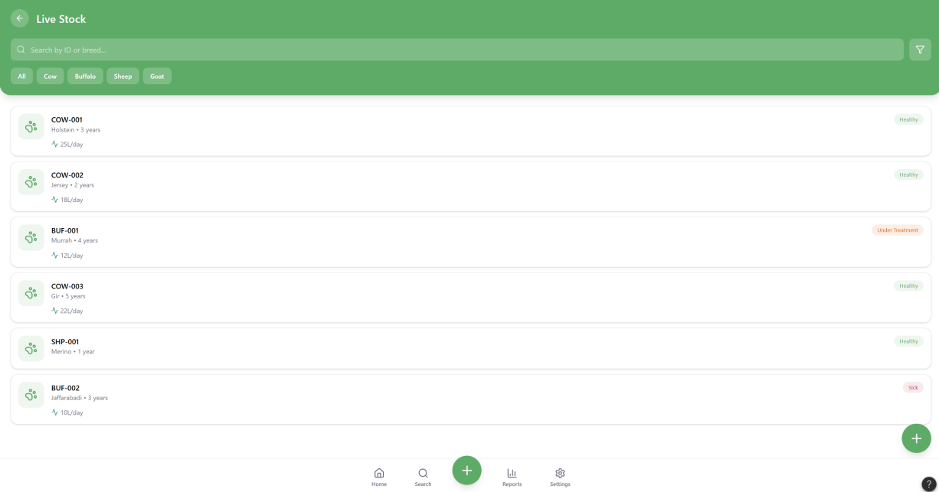

When we click to add animals in live stock management.
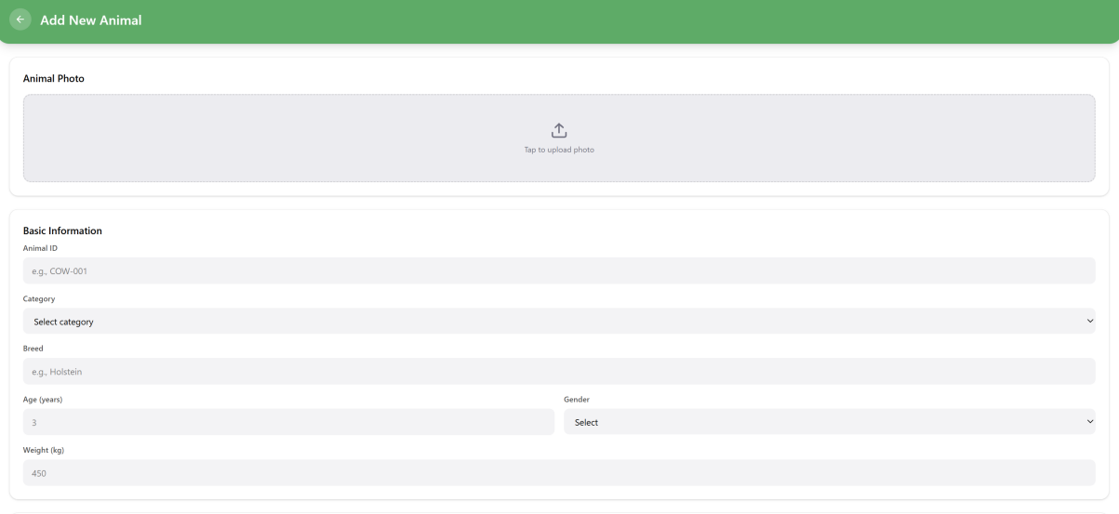
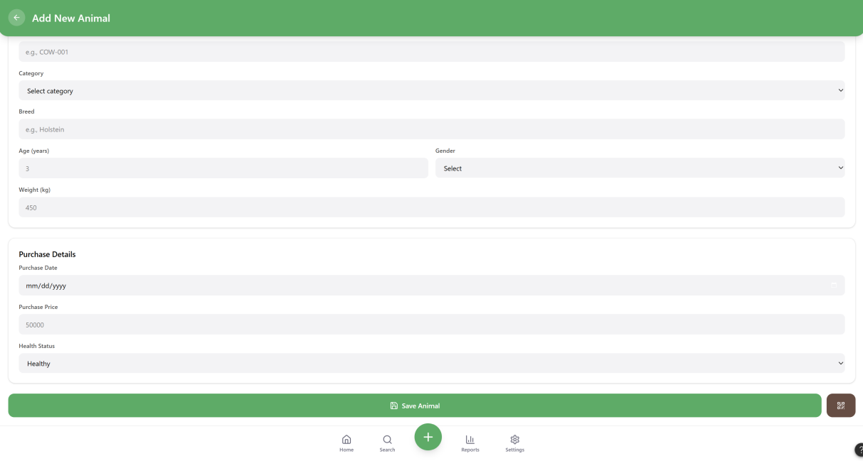
Also it uploads pics, and make qr code of which user gives info user can view or download qr code for animal tag in which qr code contains info of animal,
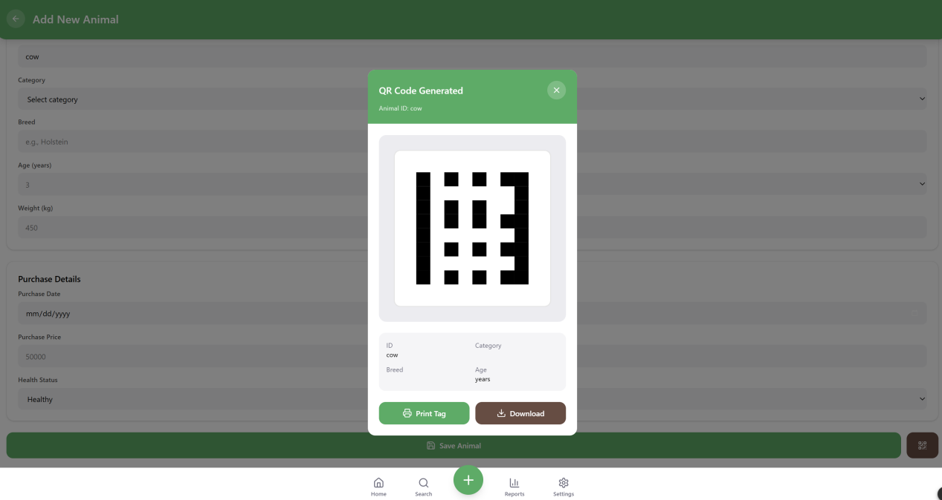
See while I give some info of animal
when I click on qr code It generates the qr code of animal,

Health :
In health management we have 2 main options I.e Vax=ccinations and checkups
In vaccinations we have data og animal when vaccinated last and when vaccination will next etc as you see , we can also schedule vaccination of any animal from live stock using this “+ “sign in vaccination page .
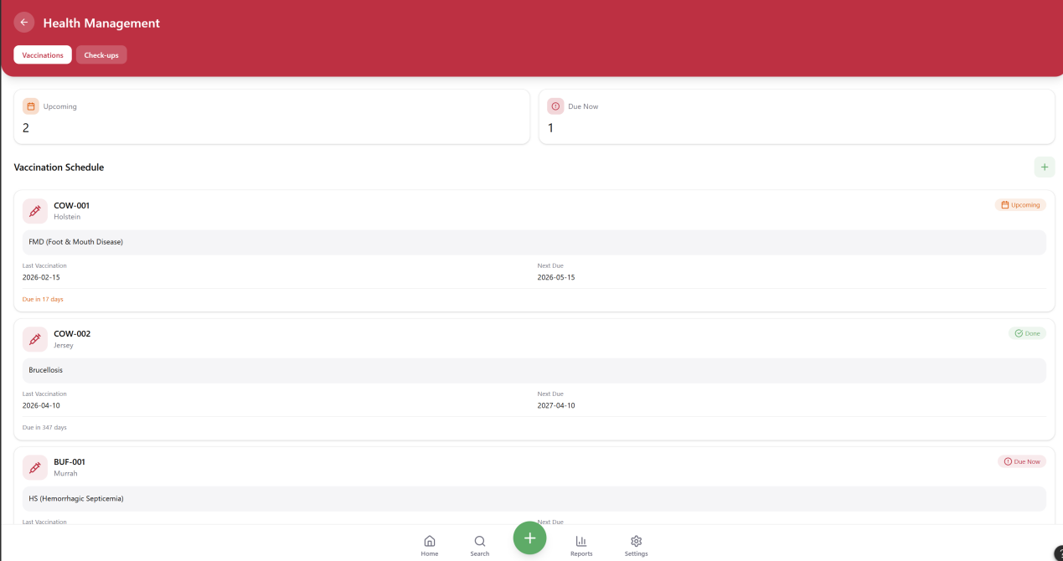

In checkups we can schedule any checkup of animal
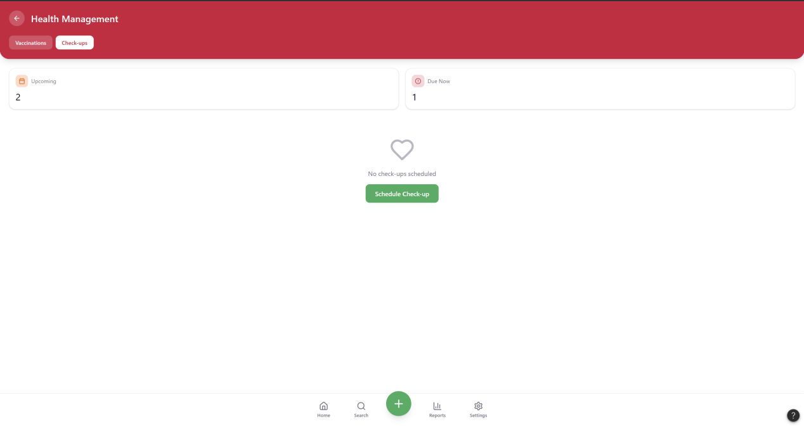

Production and sales :
We have main 4 features in this ie overview,daily entry, sales , compare.

Overview:
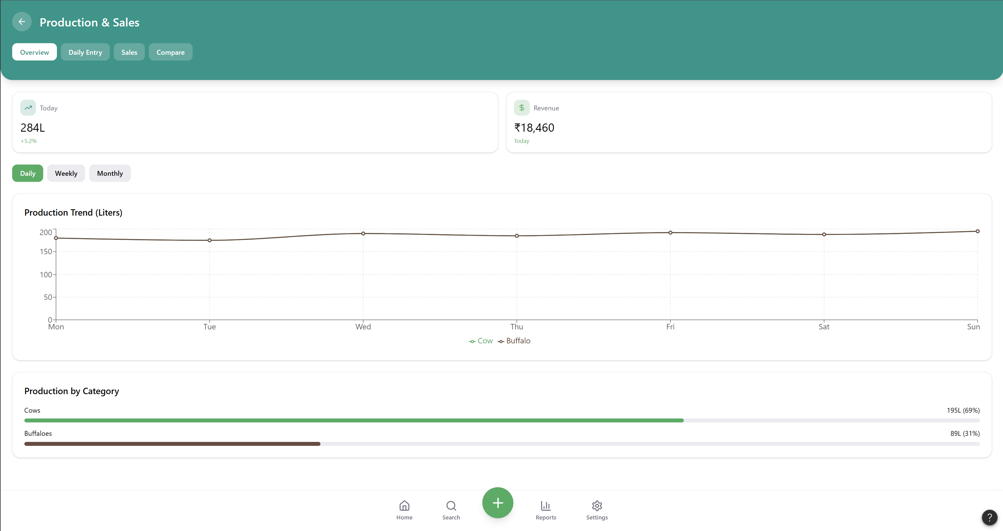

Daily entry:
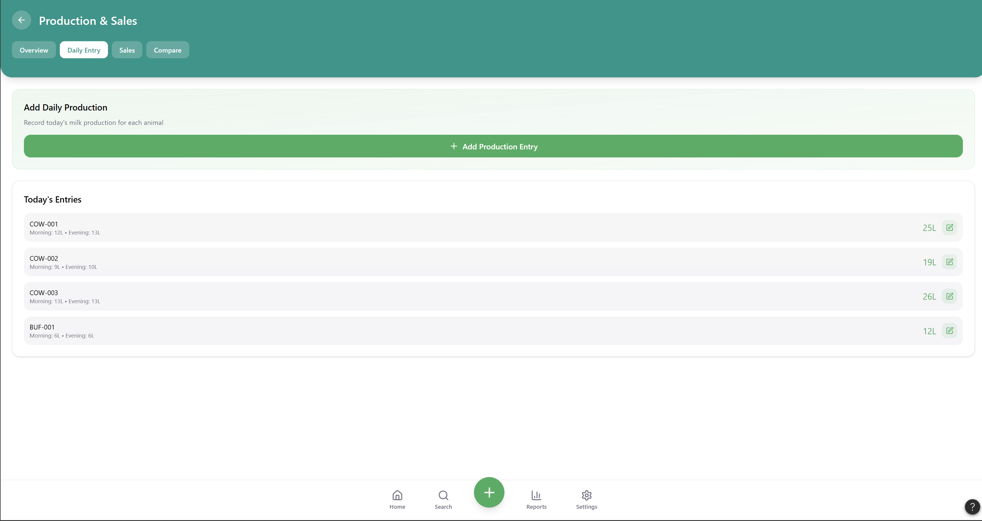
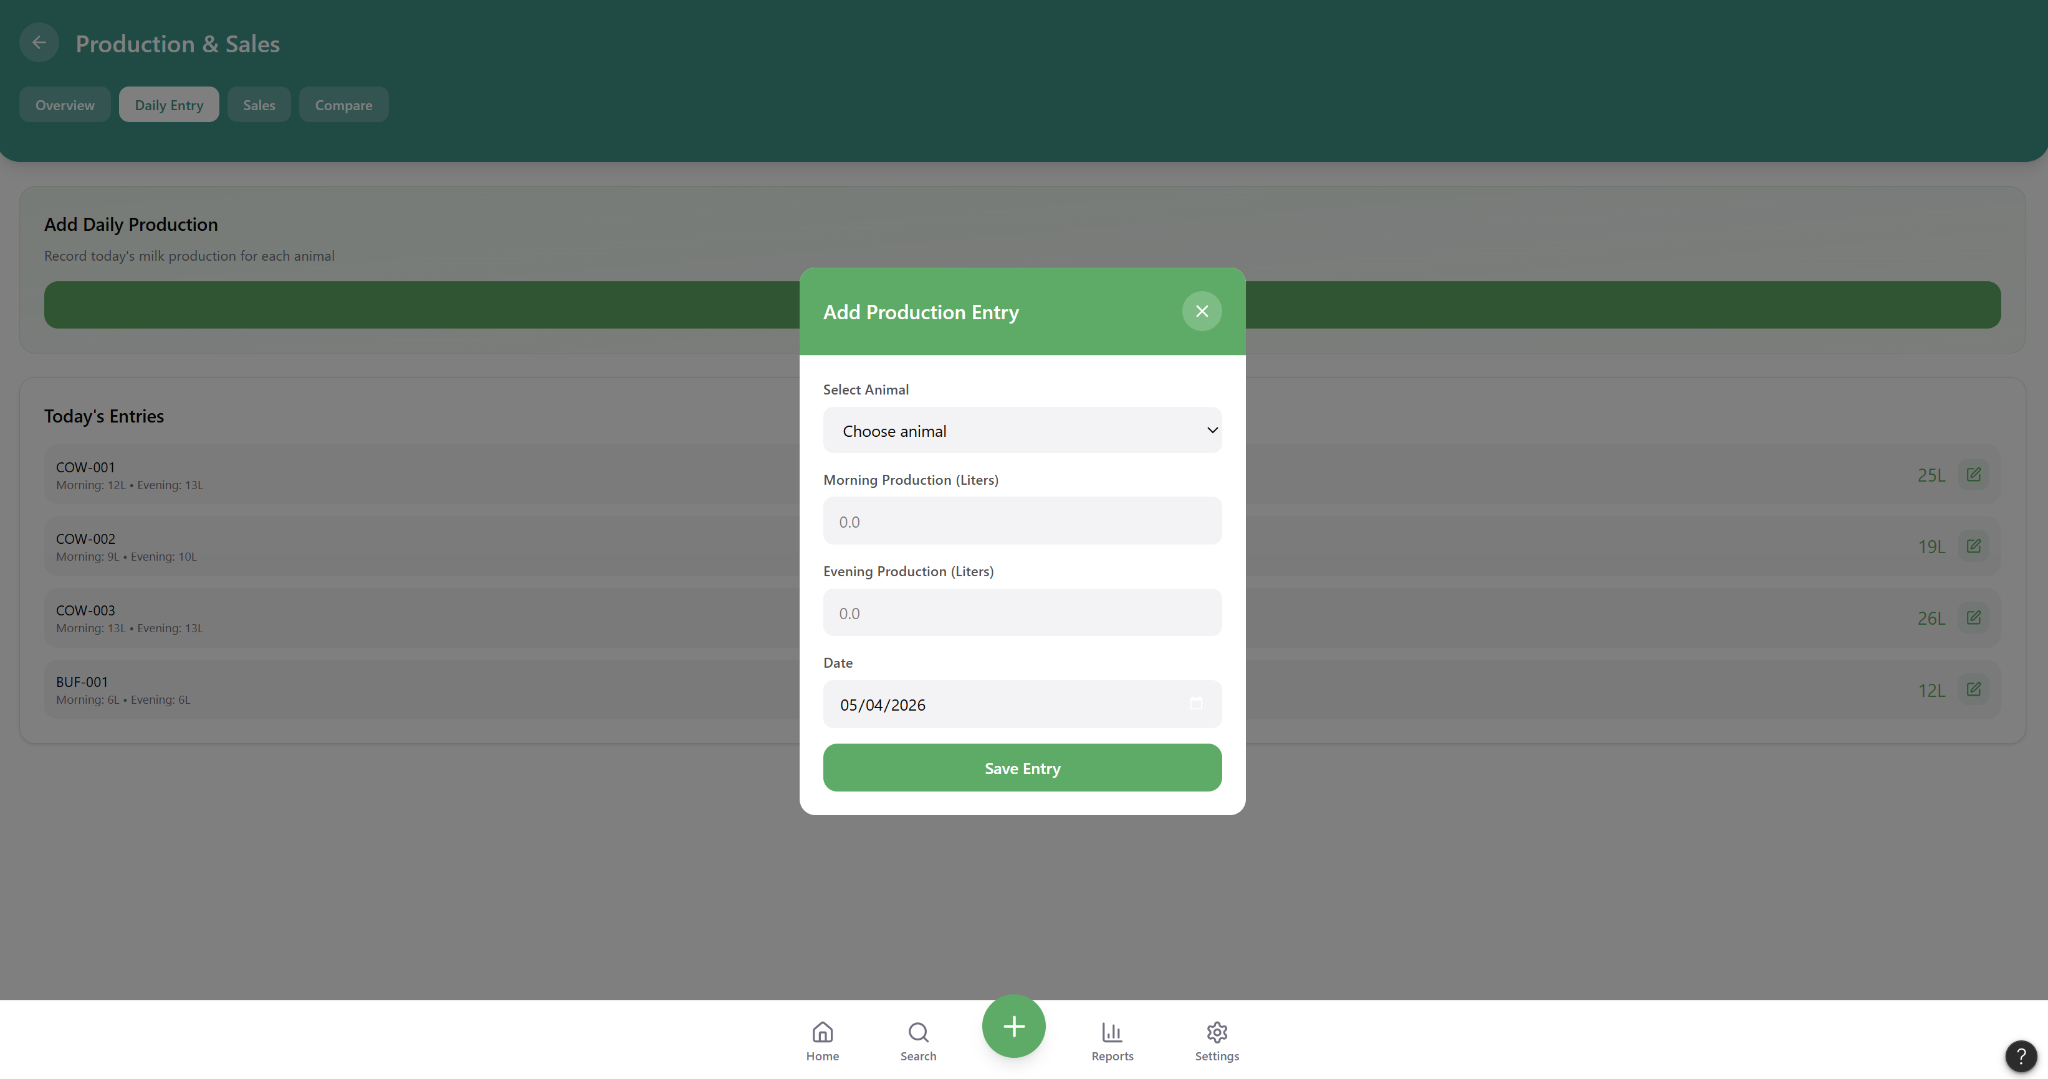
We can also add daily entry .

Sales:
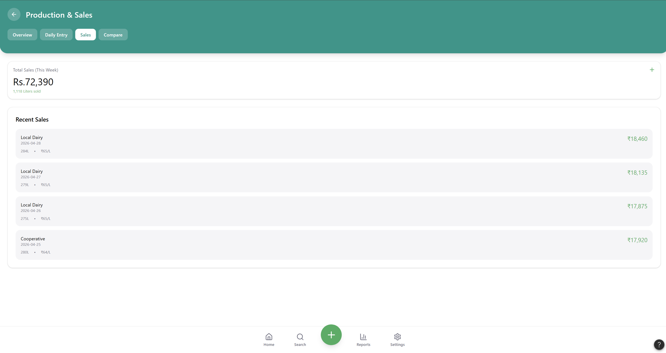
Add utton in which we add sales daily through this add button

Compare :
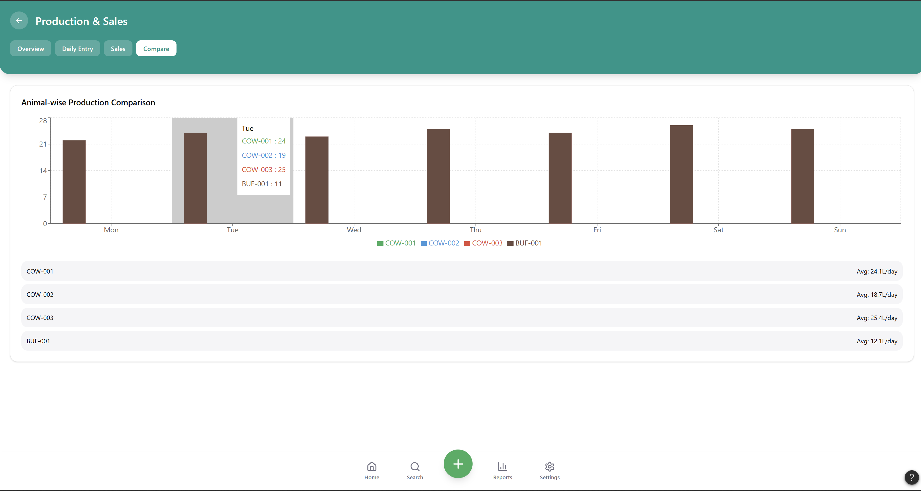

Finance and operations:
We have 4 features in this ie Overview,Expenses, profit and loss analytics , Labor.

Overview:
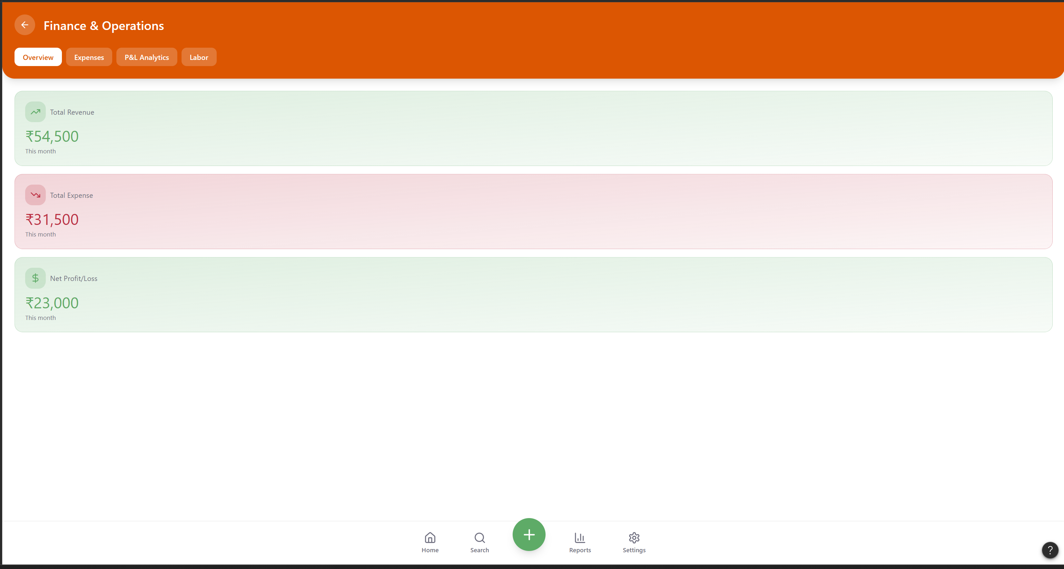

Expenses:
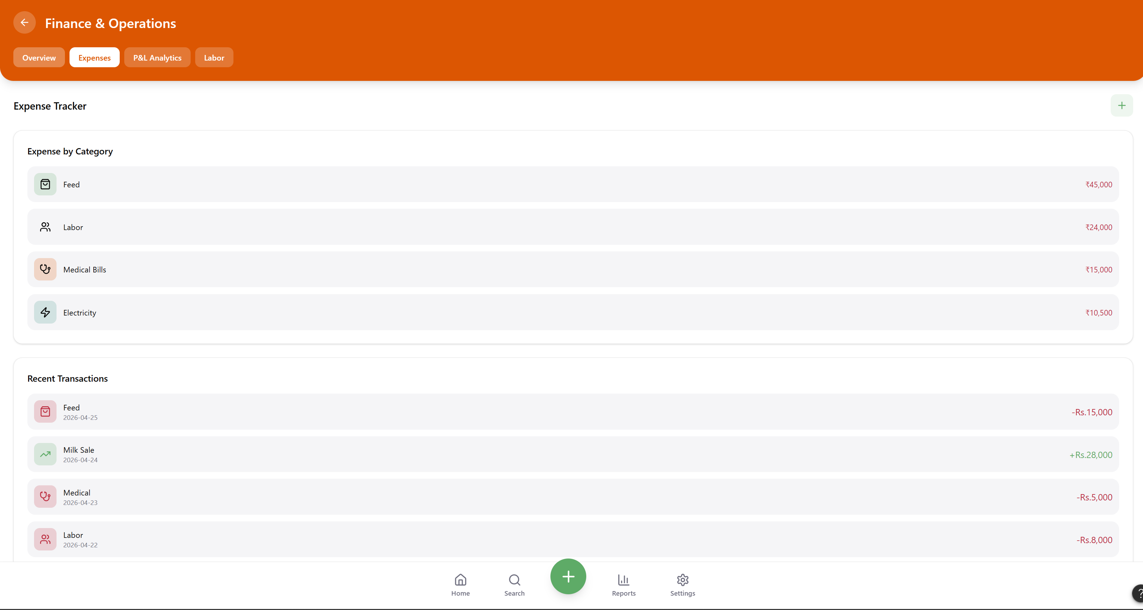

profit and loss analytics:
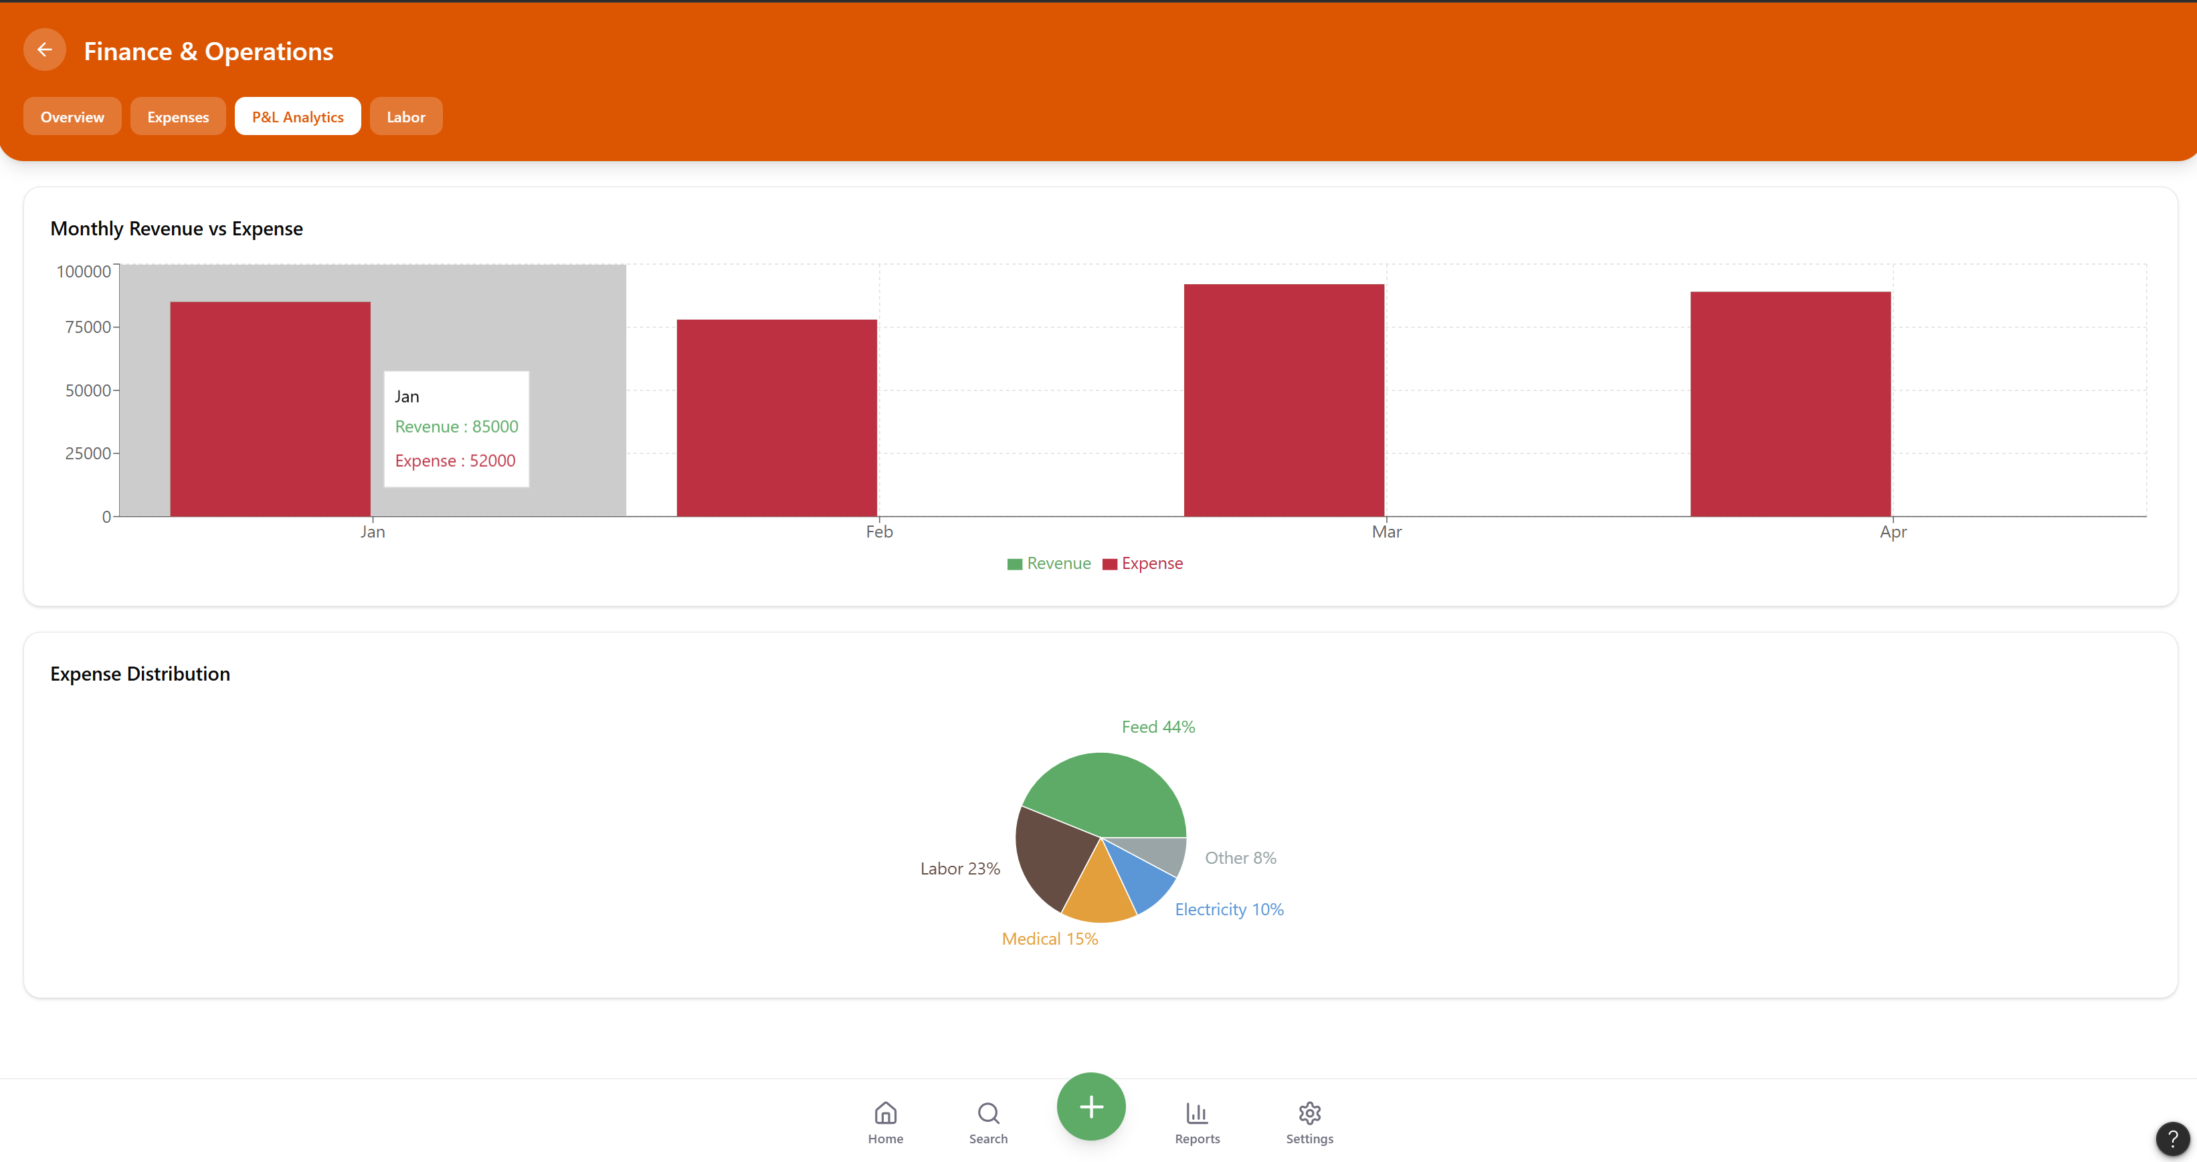

Labor:
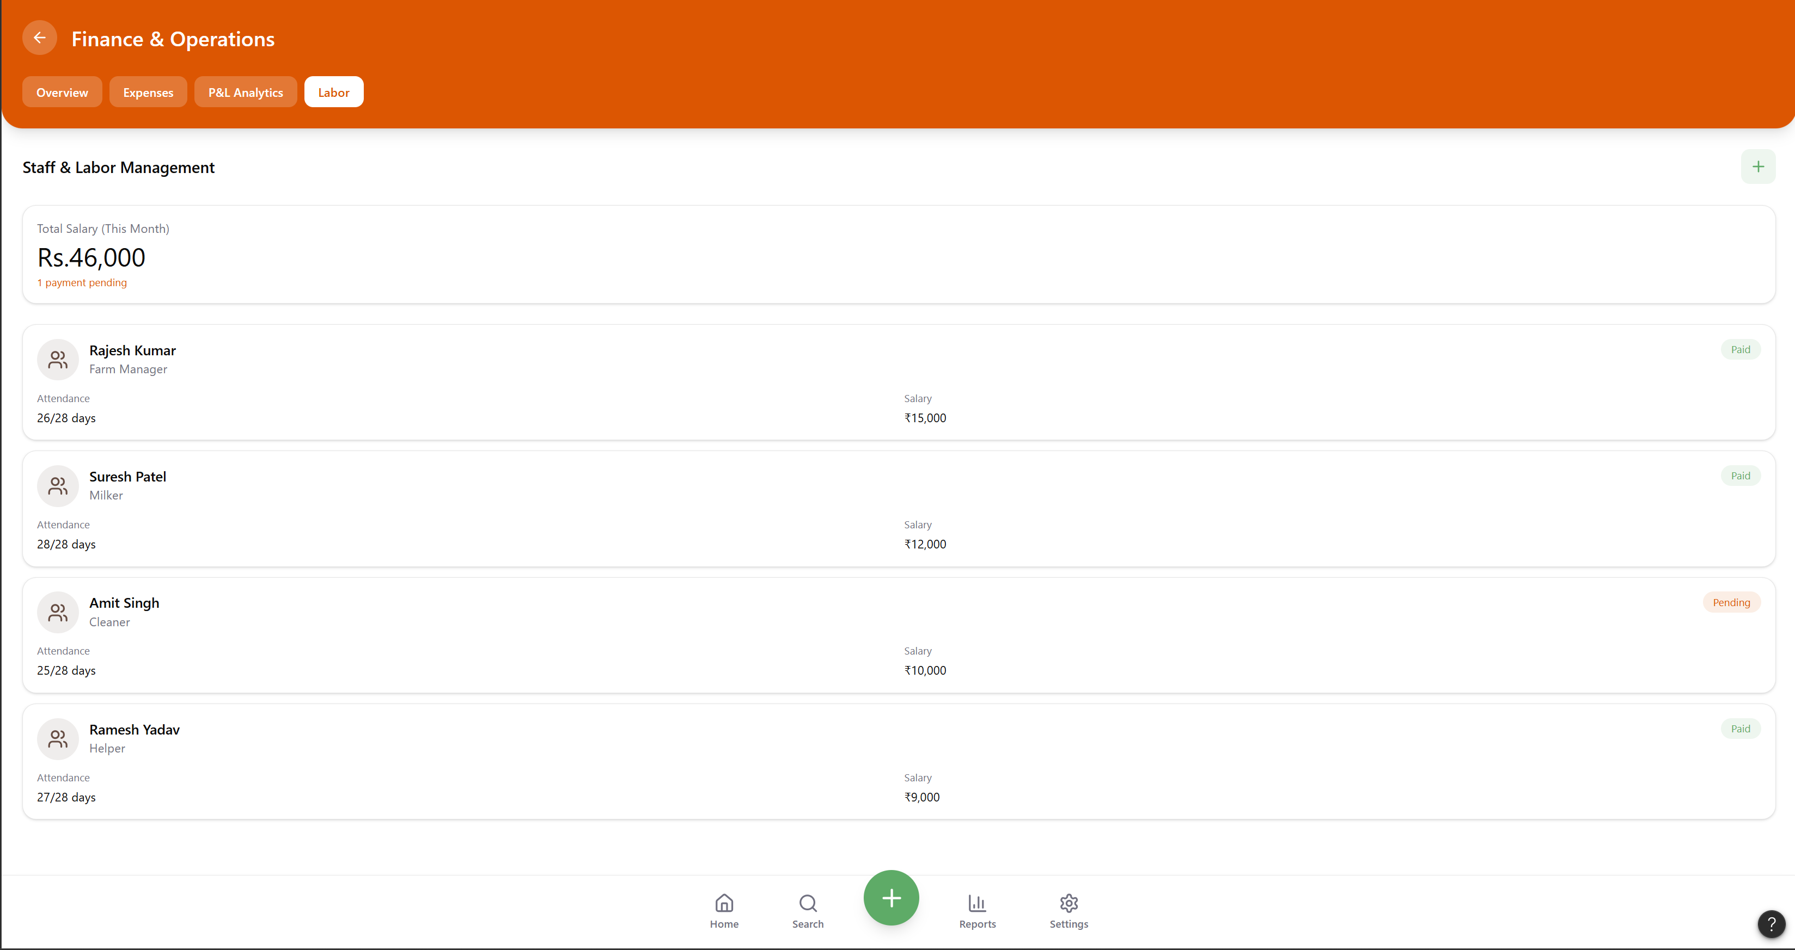

Staff management:
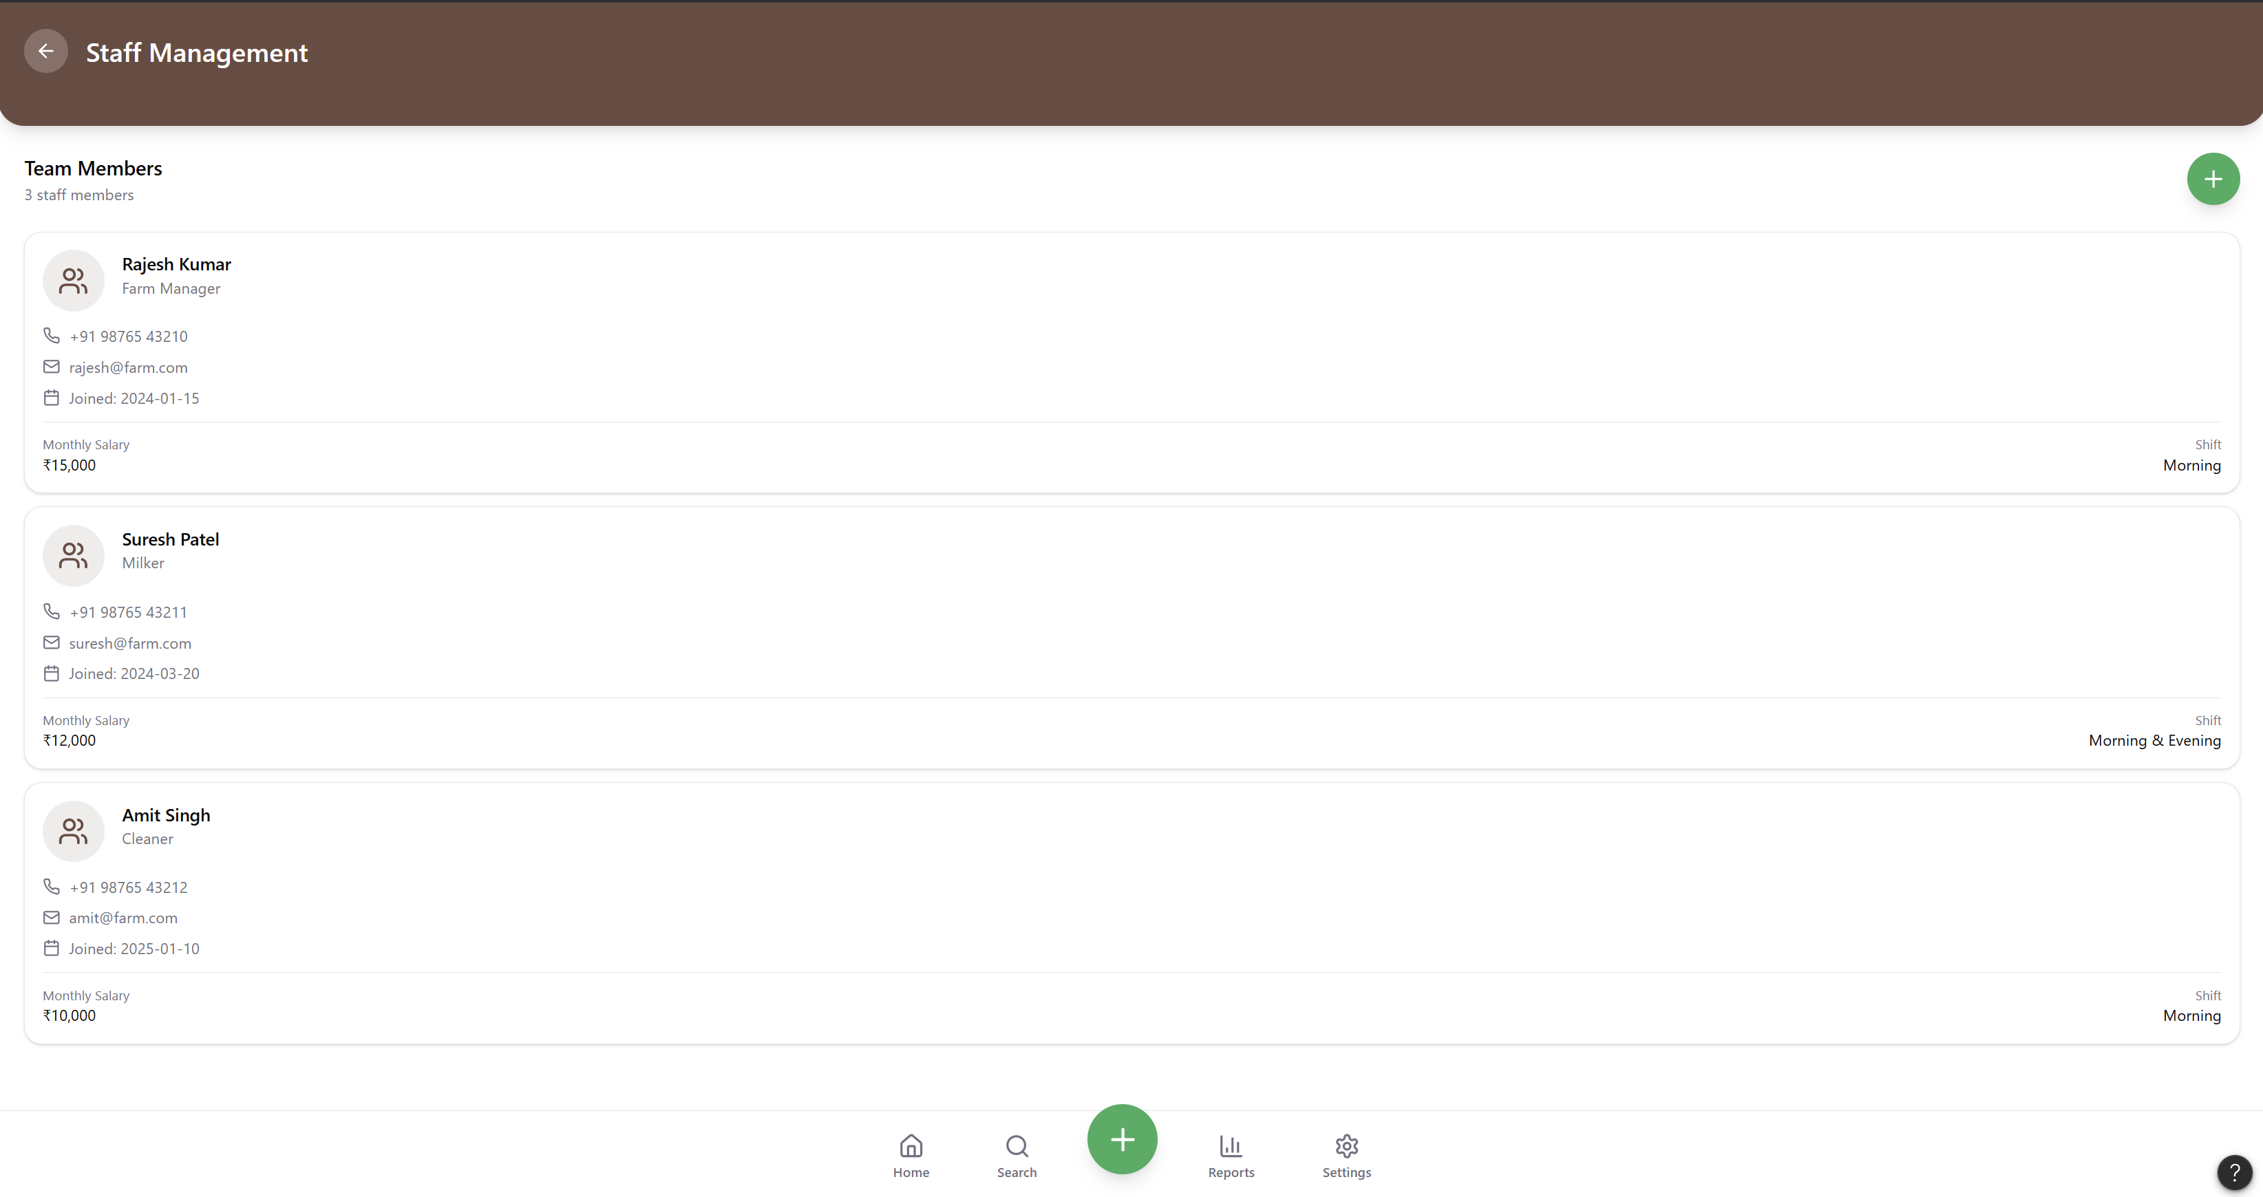

We can add new employee through this
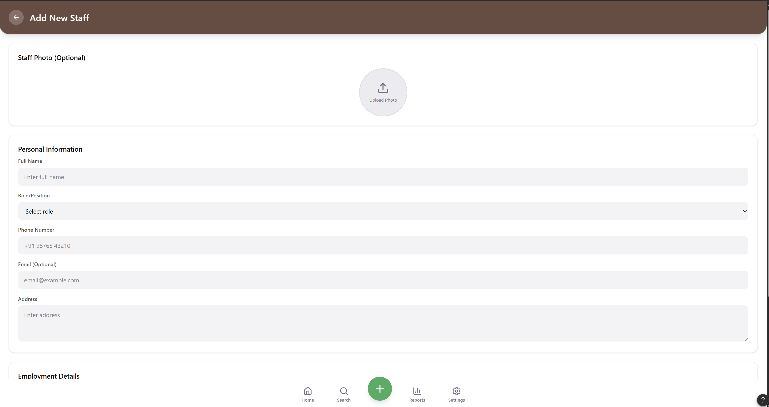
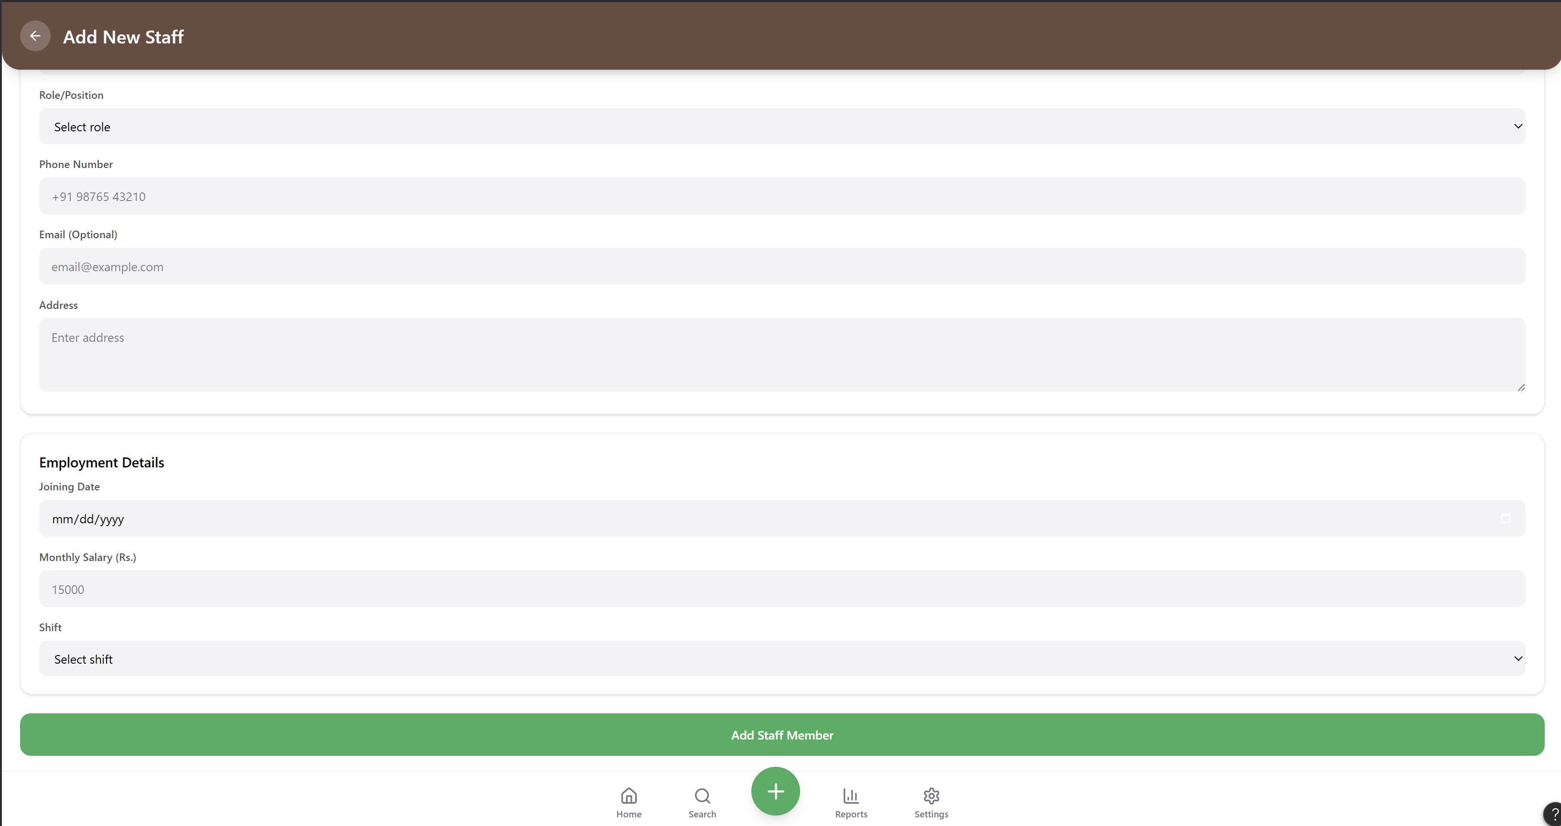
Inventry management:
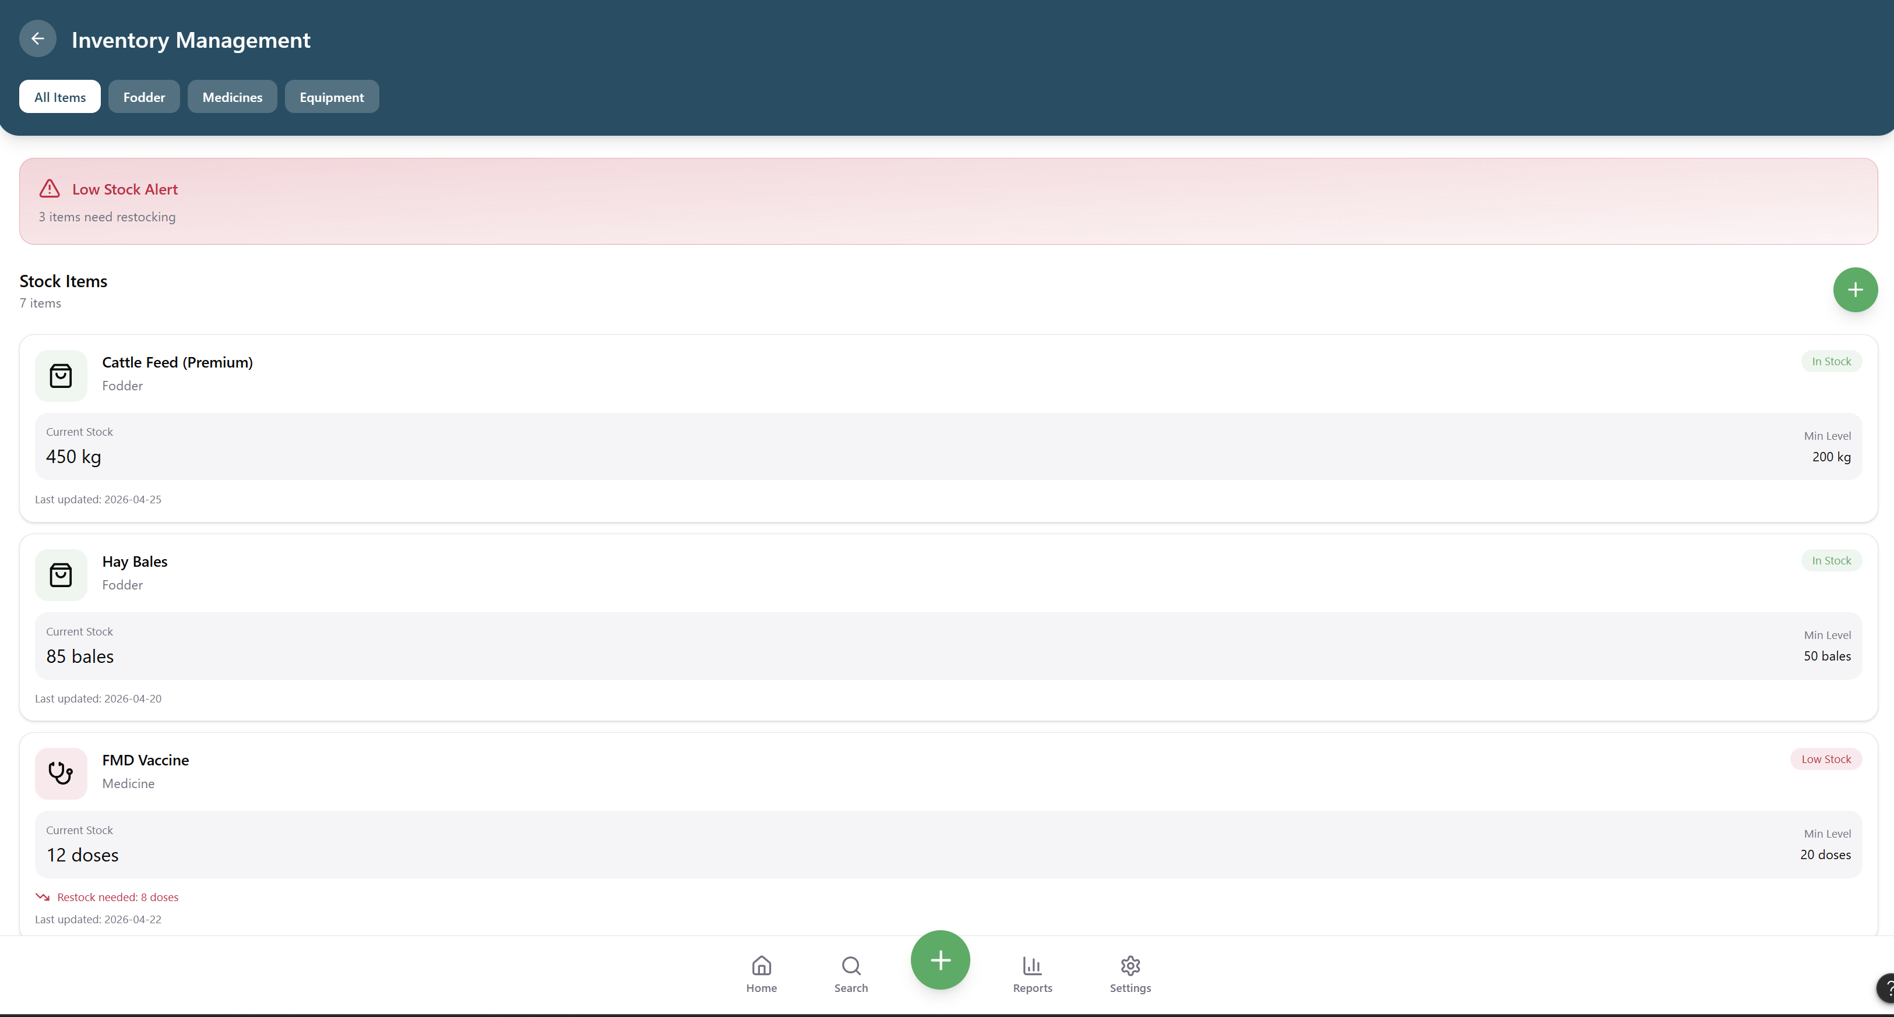

We can add through this
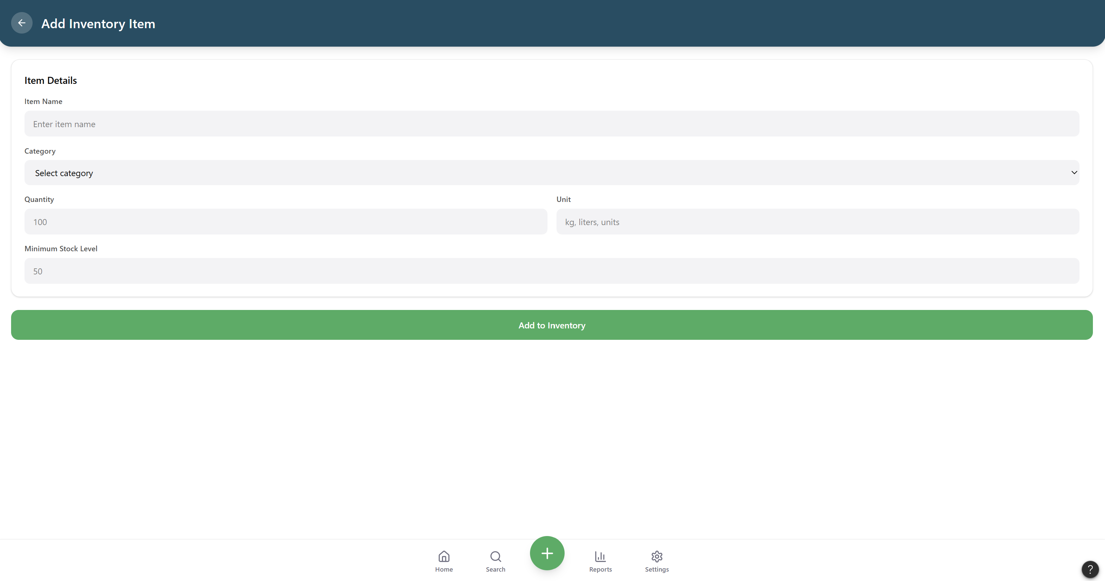

Crop details:
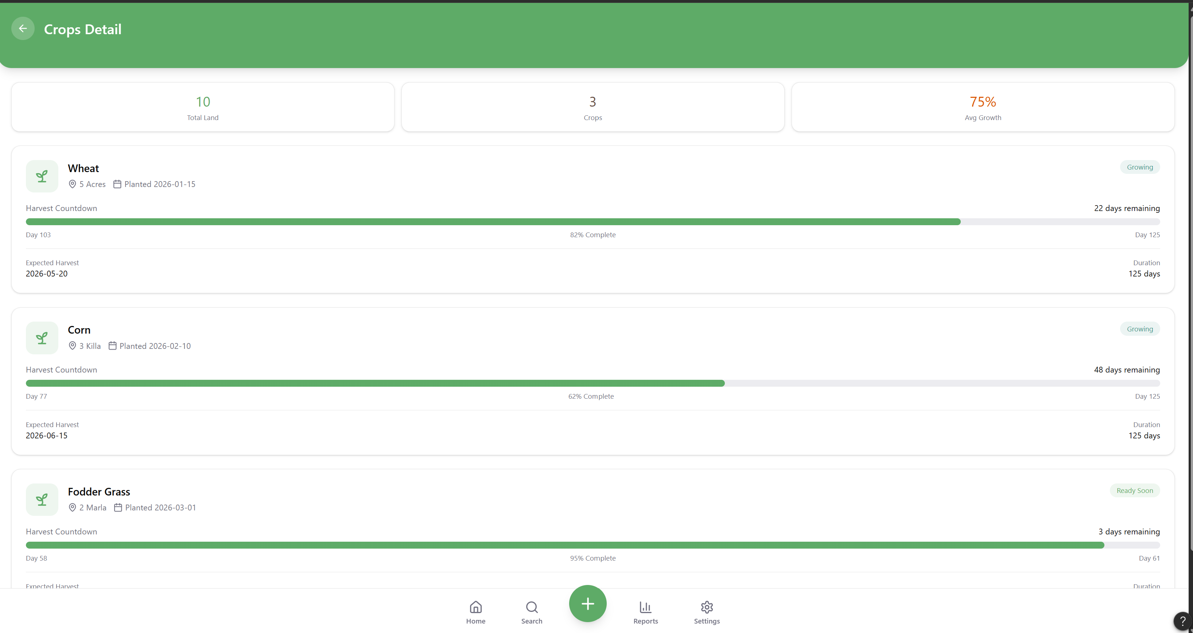
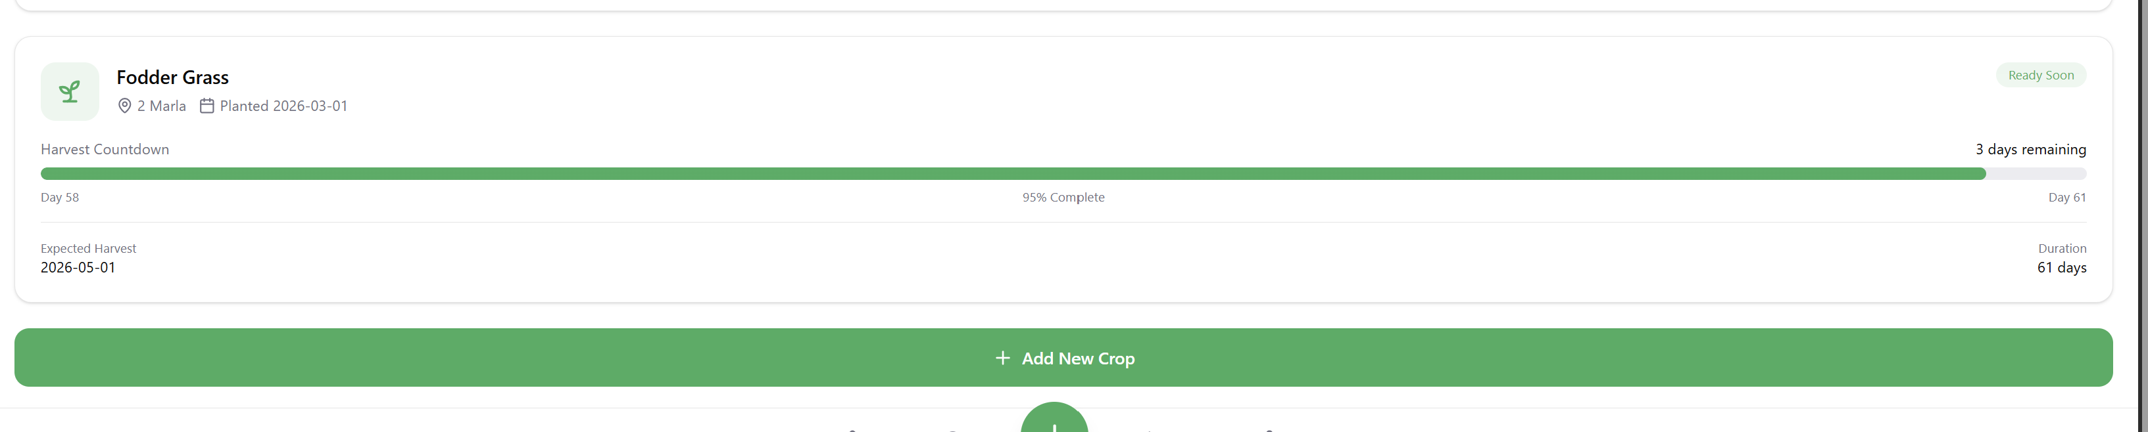
We can add crop details through this

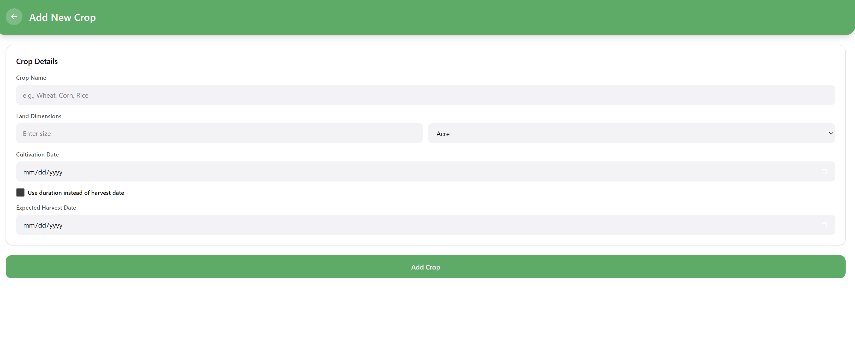
This page is for add crops cultivations etc

Bottom Nav bar:


We have 4 features ie home ,search ,add animals, reports (which will from production and sales)
And setting

Setting :
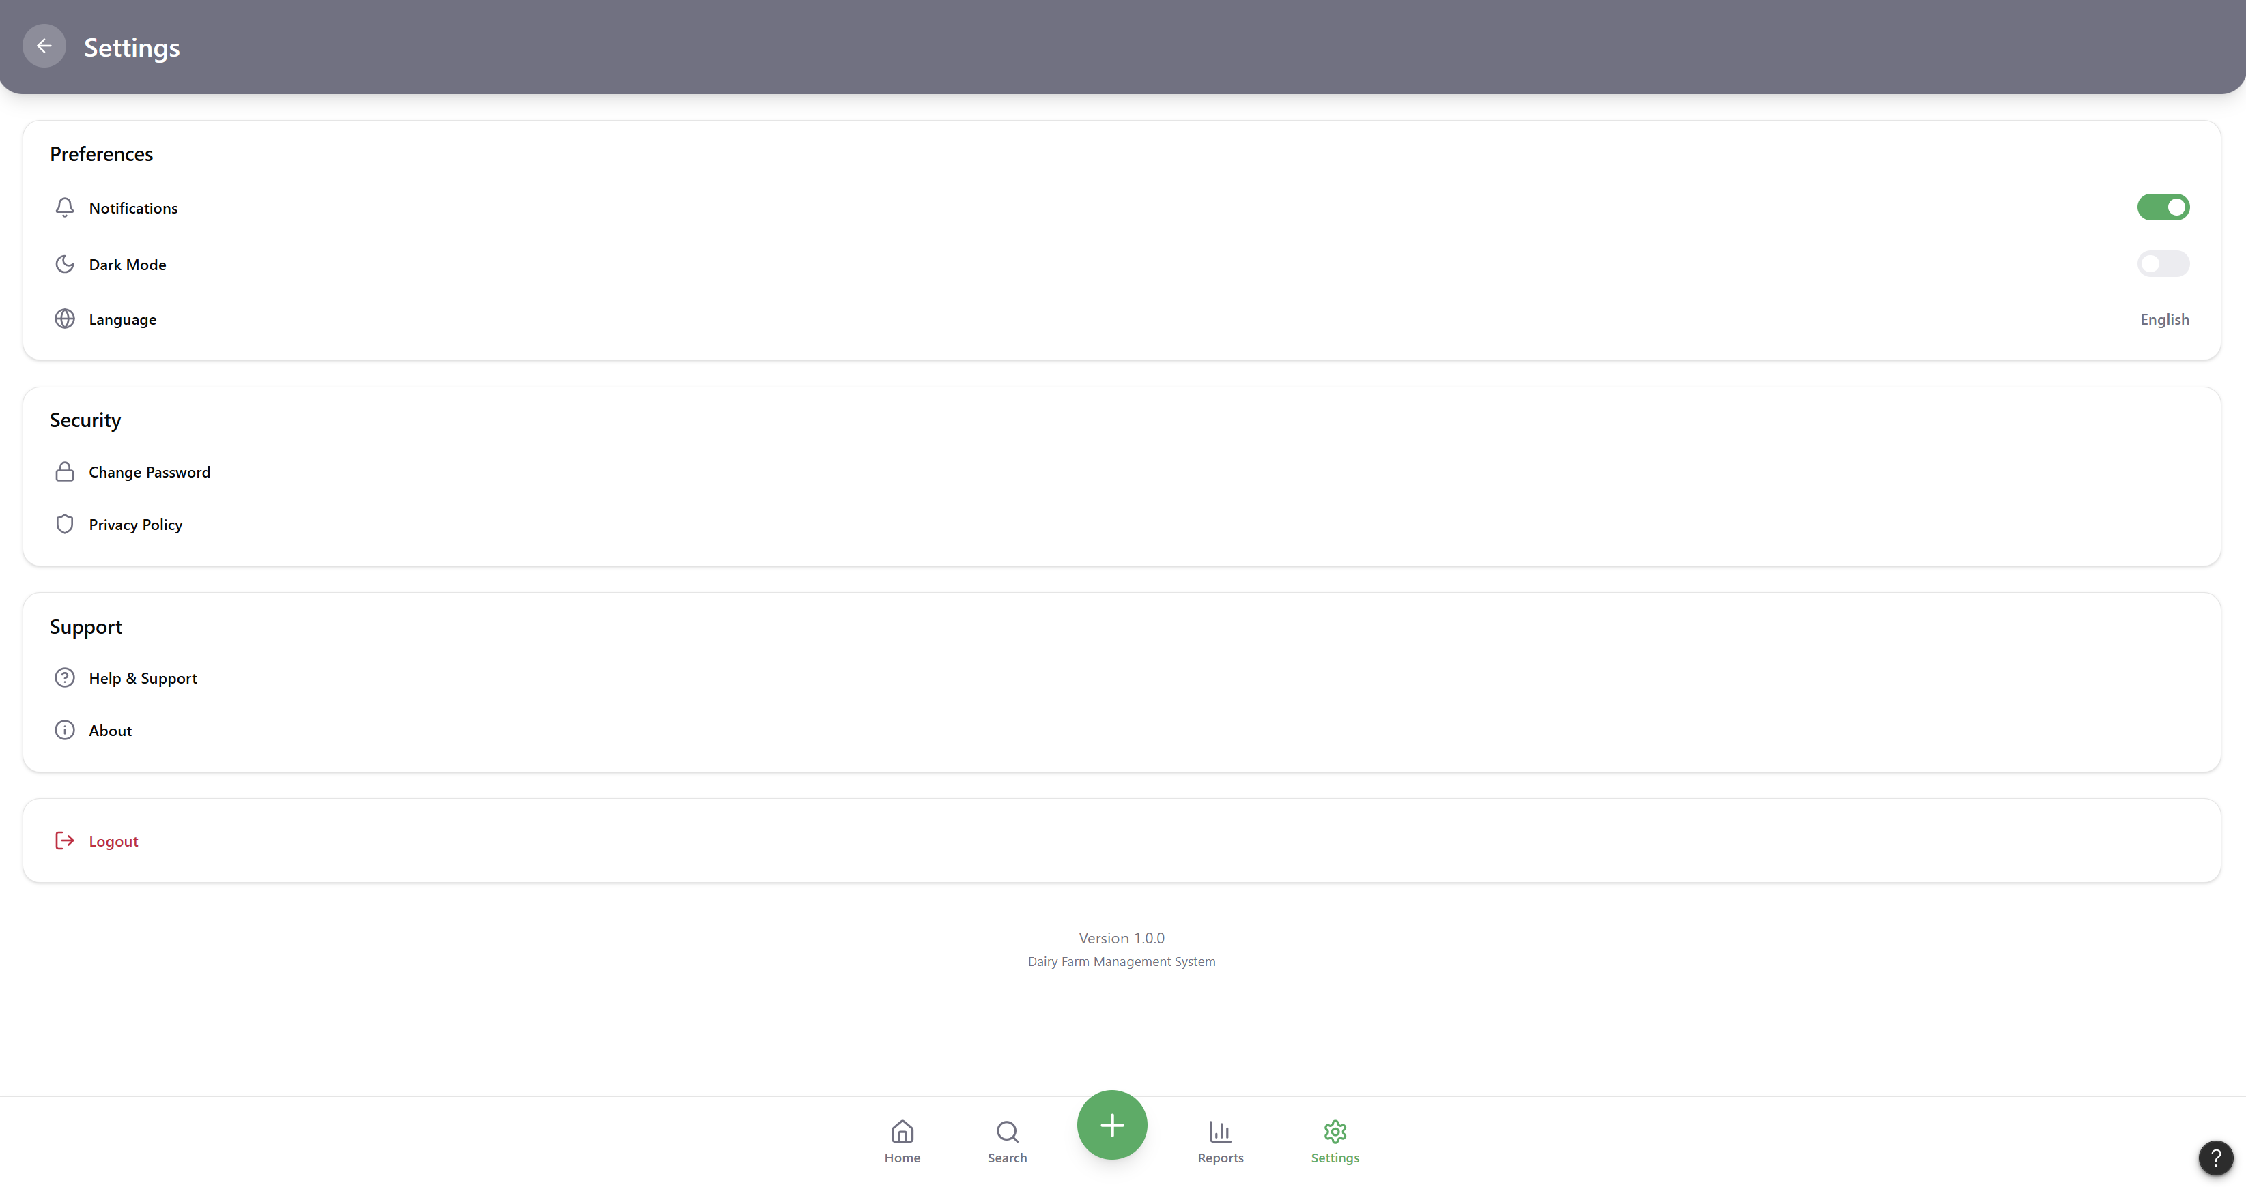

Make react native for this and full stack working app .

